**Tugas week 8 advanced bda QUIZ Christopher Darren 00000054804**

1) How many unique values does Company have? Job Title?

Answer:12 for Company, and 9 for Job Title

Screenshot the Value of Company

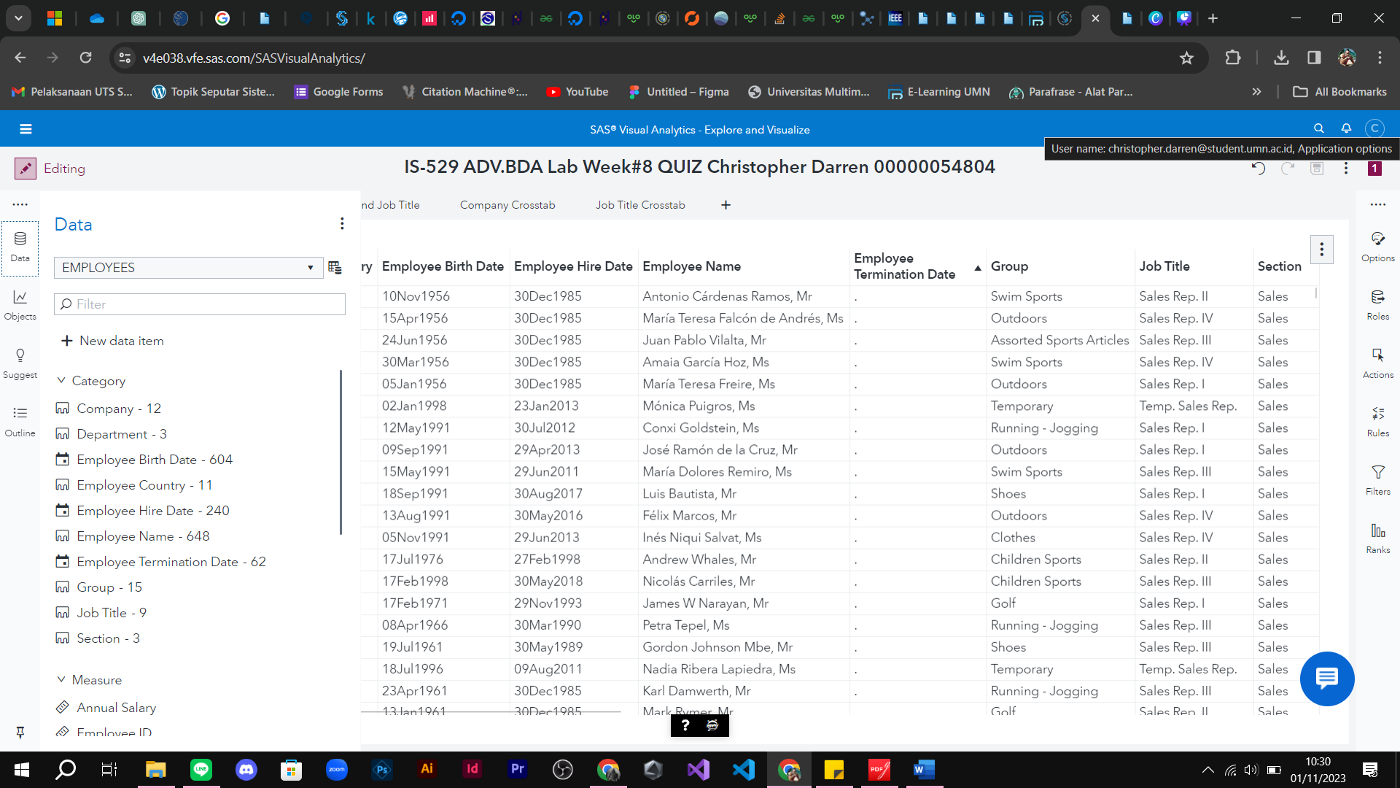

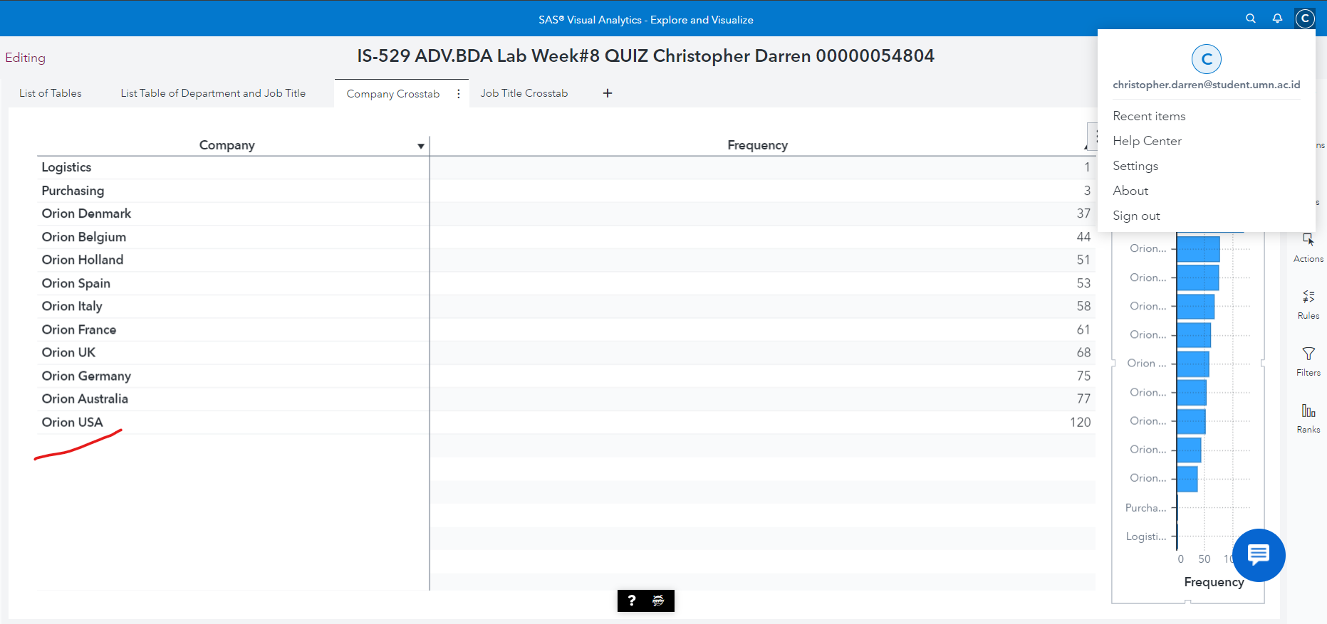

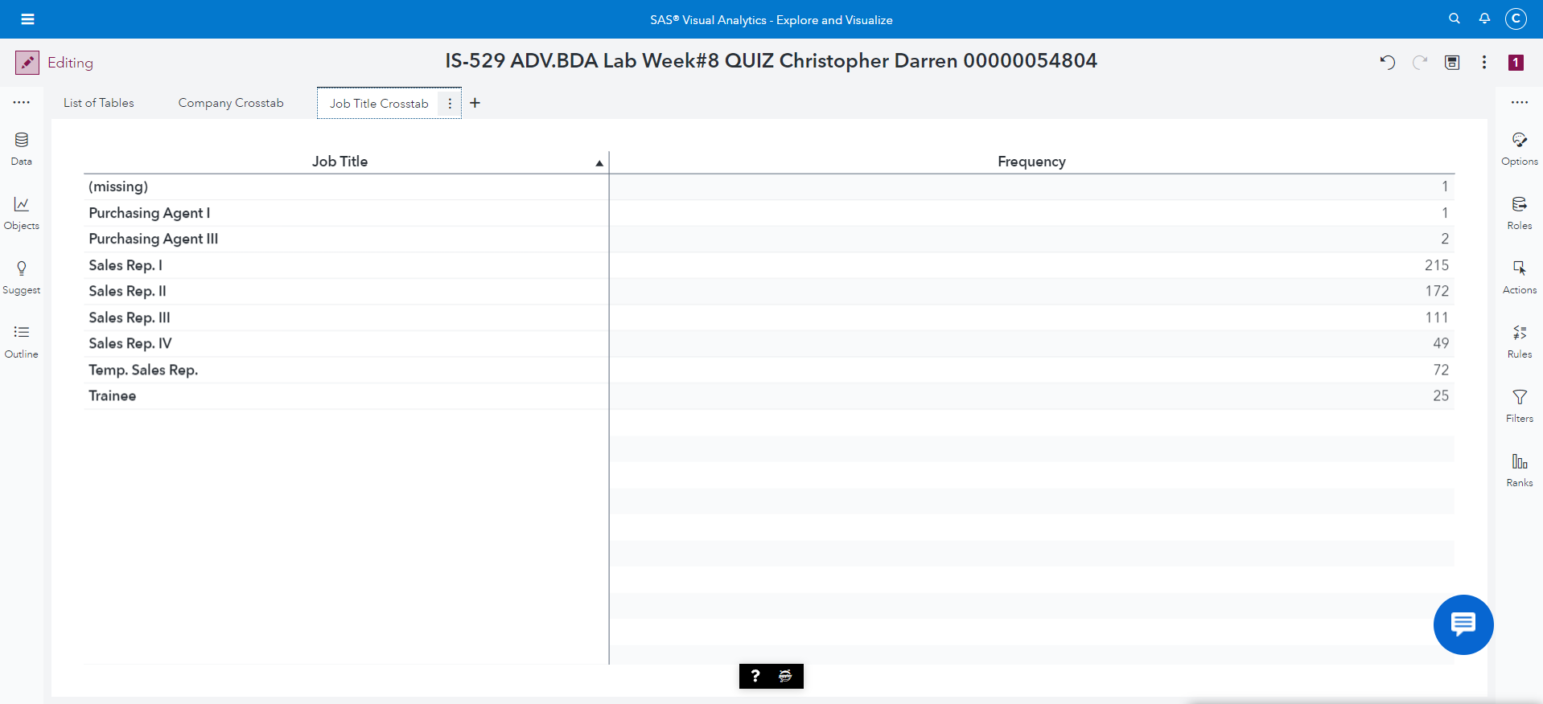

2) What is the type (or classification) of Employee ID?

Answer: NUMERIC type , classification = Measure

Screenshot of Employee ID Classification

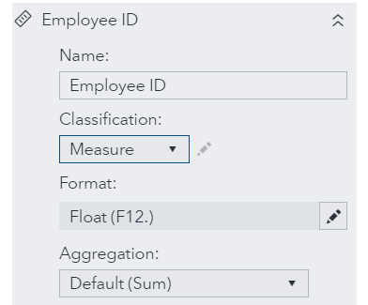

View the **list table of all data items** on Page 1 and answer the following questions:

3) What is the case of Employee Country?

Answer: LOWER CASE

Screenshot the content of Employee Country

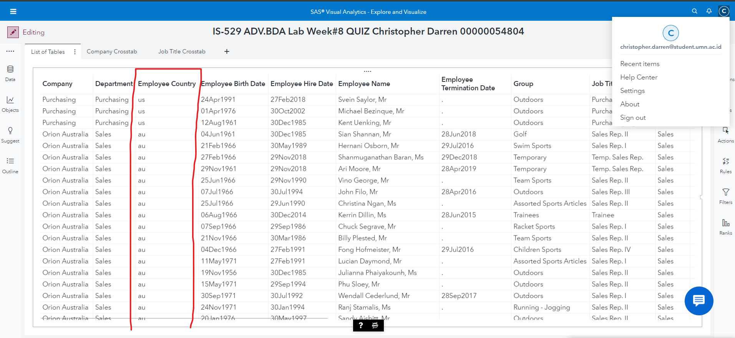

4) Which employee represents sales for winter?

Answer: 26

Screenshot of the name of Employee

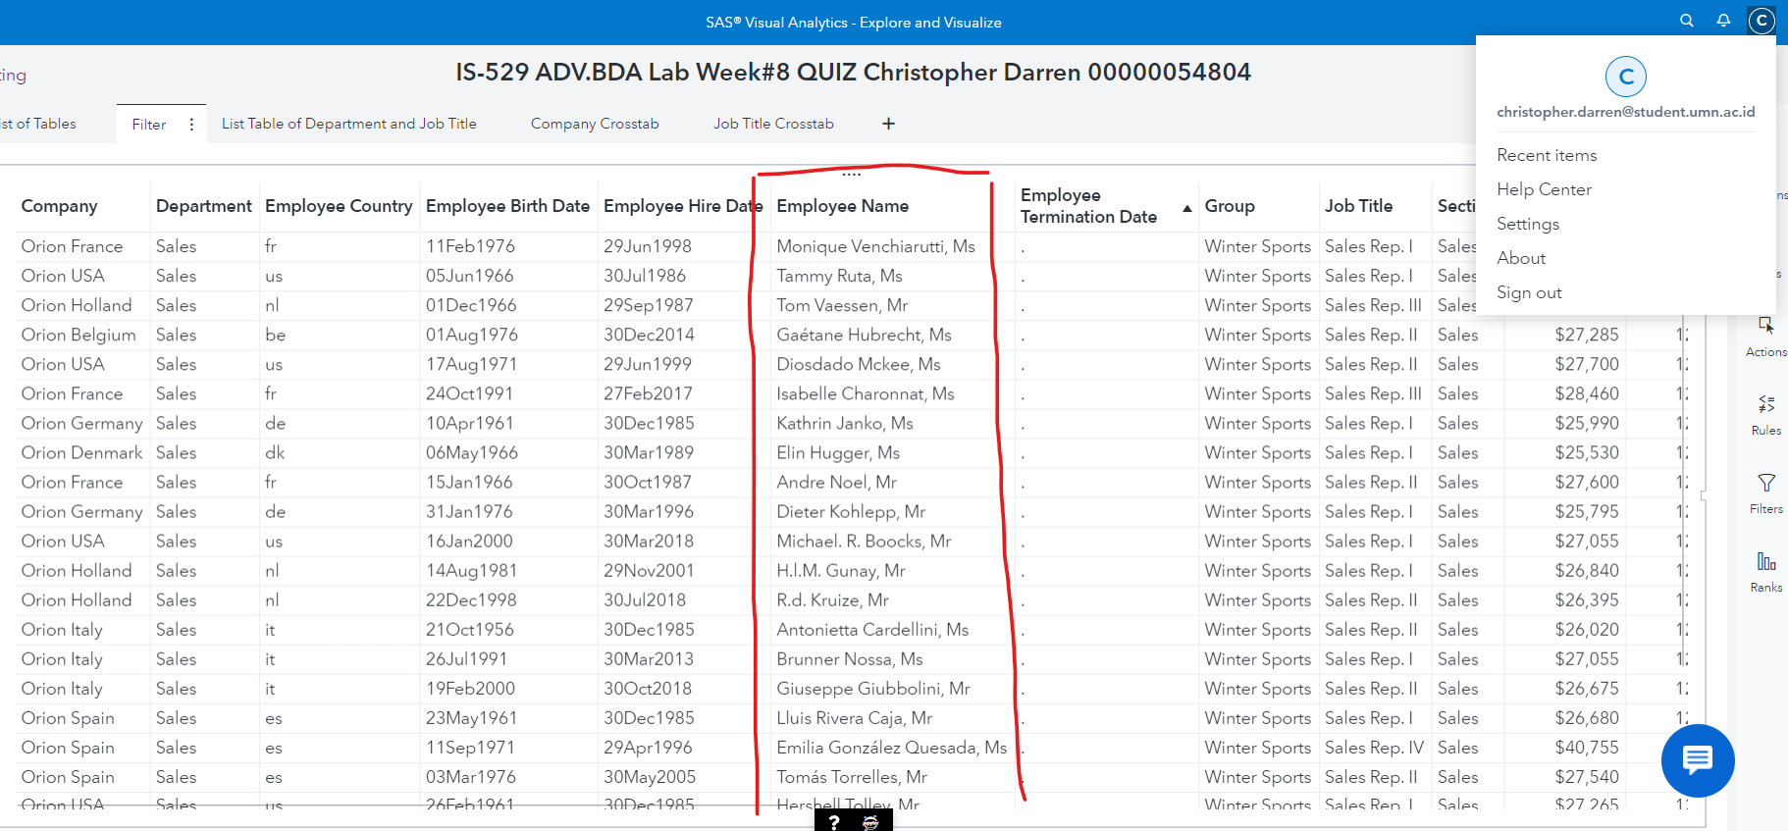

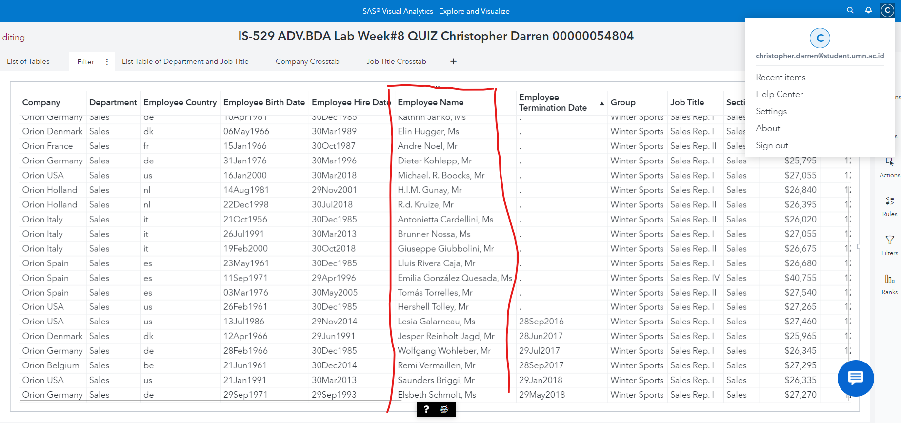

5) Which data item can be used to determine whether an employee is active (currently employed) or retired (formerly employed)?

Answer: jika pada kolom termination date tidak ada tanggal maka pekerja tersebut masih bekerja, namun jika pada kolom termination date ada tanggal maka pekerja tersebut segera akan keluar

Screenshot of the content of Emp_Term_Date (active vs retired)

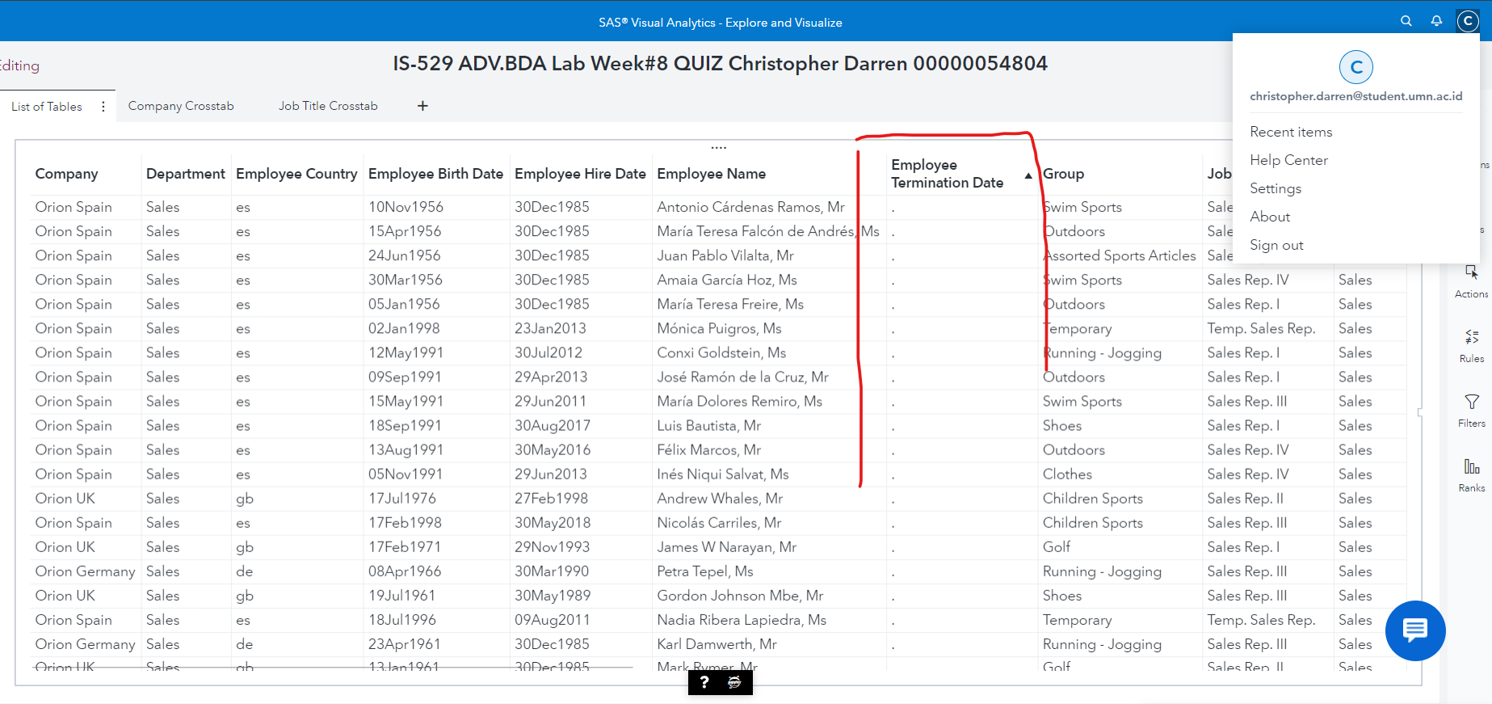

Active

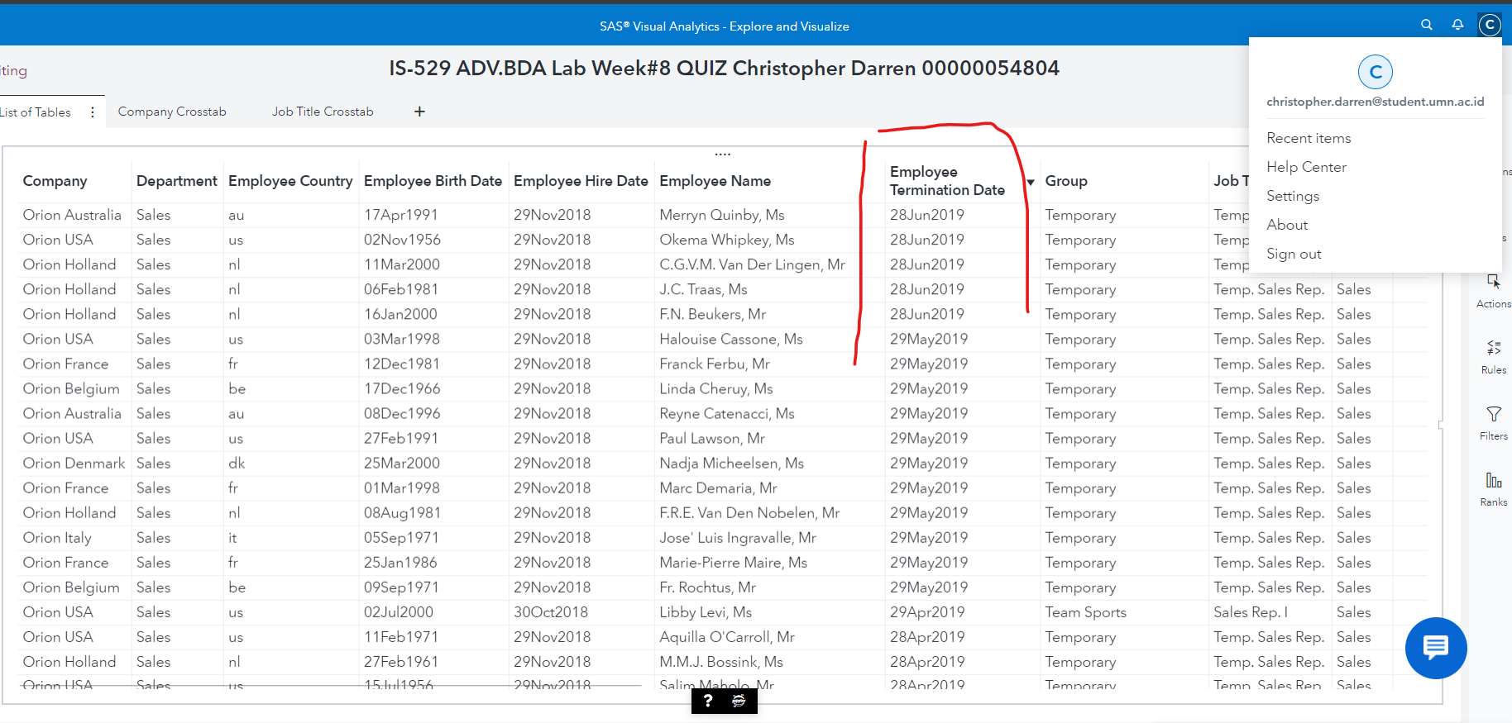

Retired

View **the list table of Department** and **Job Title** on Page 2 and answer the following question:

6) Which department contains the missing job title?

Answer: Stock & shipping

Screenshot the content of missing job title

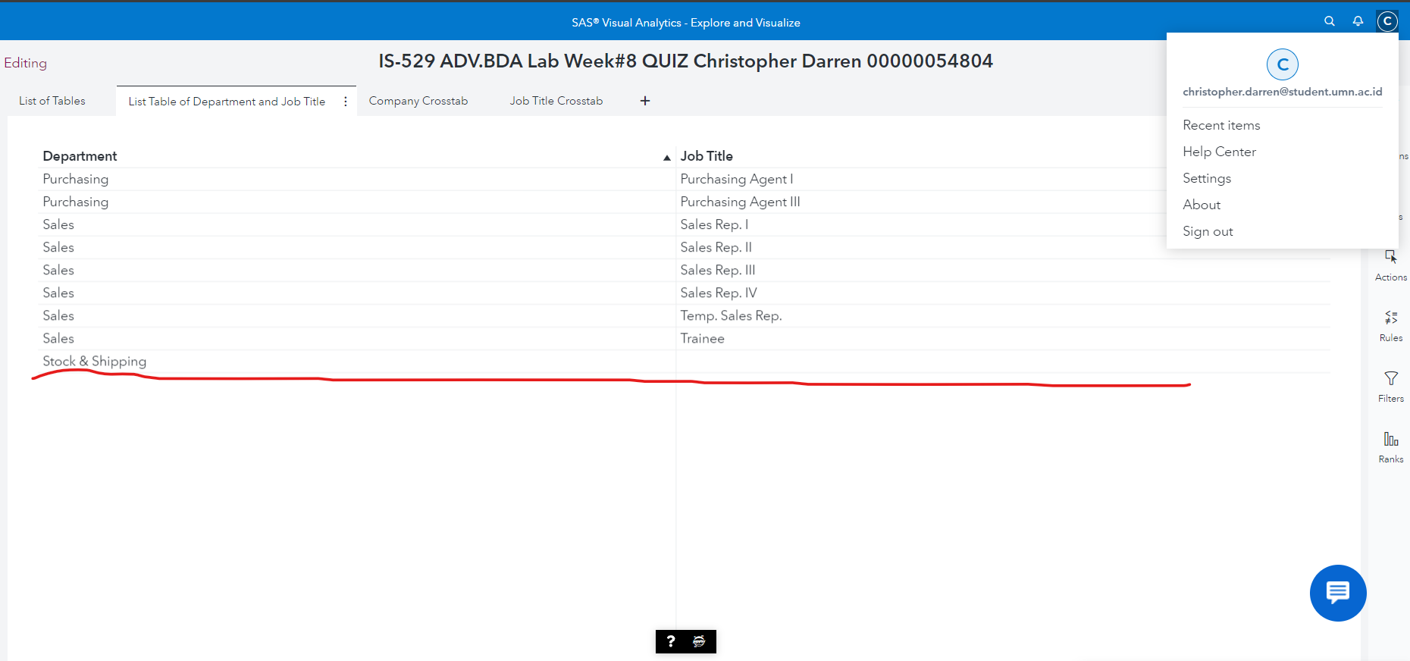

**Create an auto chart of Company** (on the right side of the list table) and answer the following questions:

7) What is the largest company, based on the number of employees? The smallest?

Answer: Orion USA the largest 120, the smallest is Logistics which is 1

Screenshot the chart of Company Frequency

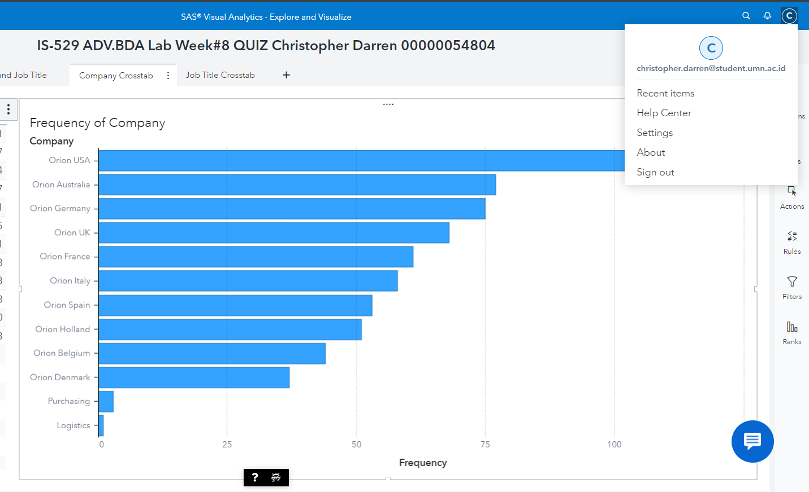

View **the measure details** (from the **Data pane**) and answer the following questions:

8) What is the minimum total profit generated by an employee? The maximum? The average? The total profit generated by all employees?

Answer:

* Minimum total profit = 11.10
* Maximum total profit = 19,146,779.62
* Average profit = 109,148.07
* Total profit= 70,727,947.65

Screenshot the Min/Max/Avg/Total Profit by all employee

